JMeter Performance Testing Report
SIP & NAV Allocation Engine
Endpoint #7 — POST /api/v1/sips
Purpose
This report evaluates the performance and persistence behavior of the SIP creation REST endpoint under two 100,000-request Apache JMeter workloads. The endpoint creates InvestorSIP records in PostgreSQL. Database row-count evidence was captured after each workload to verify that successful HTTP requests corresponded to persisted SIP records.

Test 1 — High Concurrency
The first workload used 1,000 JMeter threads with 100 iterations per thread, generating 100,000 POST requests. Ramp-up time was 10 seconds.
Endpoint | POST /api/v1/sips
Protocol | HTTP
Server | localhost:8080
Threads | 1,000
Loops / Thread | 100
Total Requests | 100,000
Ramp-up | 10 seconds
Payload | userId randomized with ${__Random(1000000,9999999)}, fundSymbol=HDFC-FLEXI, monthlyAmount=5000, deductionDay=16
Expected HTTP Result | 200 OK

JMeter Test Evidence — Test 1
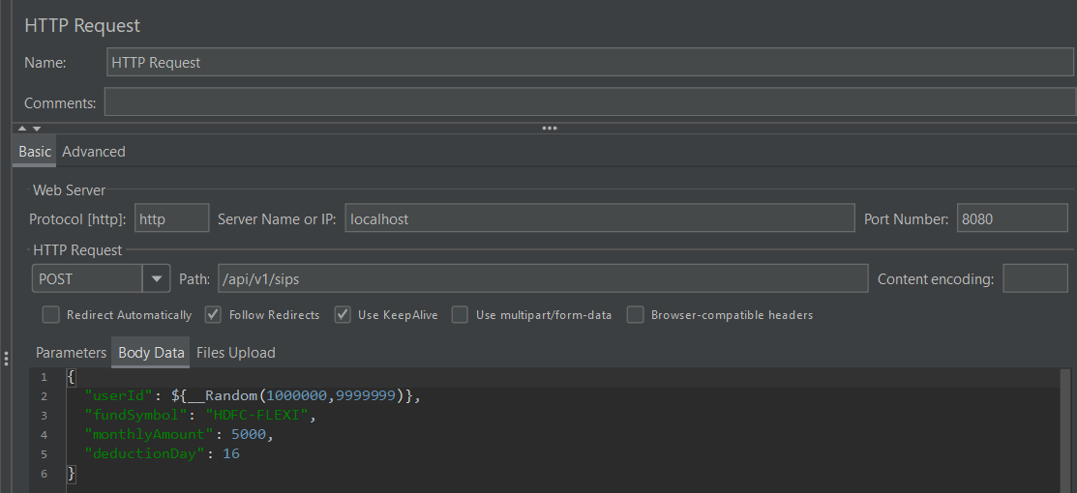
Figure 1 — HTTP Request Configuration
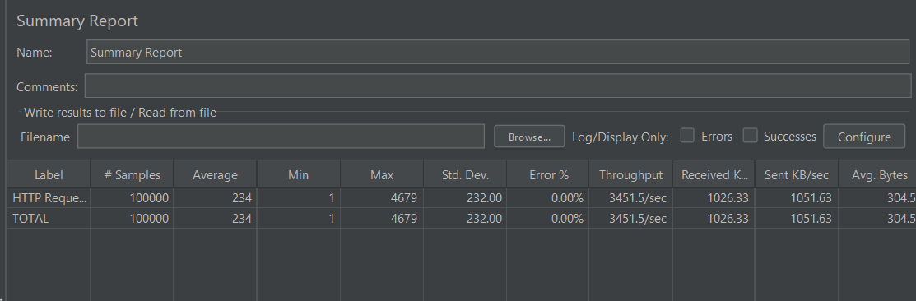
Figure 2 — Summary Report
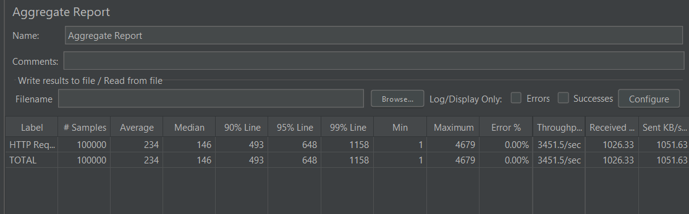
Figure 3 — Aggregate Report

Database Persistence Evidence — Test 1
Before the benchmark there were 4 existing SIP records. After the 100,000-request workload, the PostgreSQL count was 100,004, showing an increase of 100,000 persisted InvestorSIP rows.
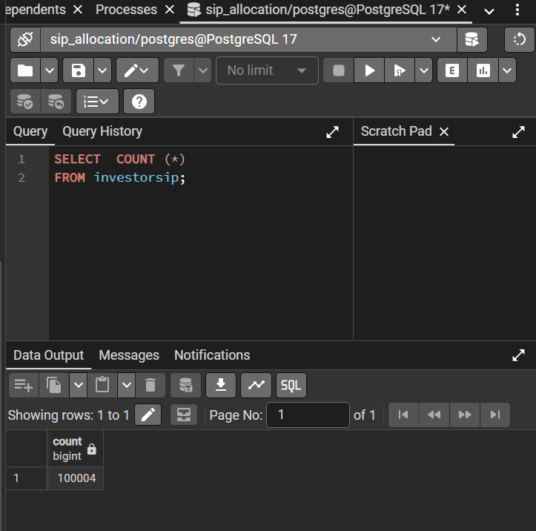
Figure 4 — PostgreSQL investorSIP row count after Test 1

Performance Results — Test 1
Metric | Result
Samples | 100,000
Average | 234 ms
Median | 146 ms
P90 | 493 ms
P95 | 648 ms
P99 | 1,158 ms
Minimum | 1 ms
Maximum | 4,679 ms
Standard Deviation | 232.00 ms
Error Rate | 0.00%
Throughput | 3,451.5 requests/sec
Received | 1,026.33 KB/sec
Sent | 1,051.63 KB/sec
Average Bytes | 304.5 bytes
Database Row Increase | 100,000

Test 2 — High Iteration
The second workload used 100 JMeter threads with 1,000 iterations per thread, again generating 100,000 POST requests. Ramp-up time was 10 seconds.
Endpoint | POST /api/v1/sips
Protocol | HTTP
Server | localhost:8080
Threads | 100
Loops / Thread | 1,000
Total Requests | 100,000
Ramp-up | 10 seconds
Payload | userId randomized with ${__Random(1000000,9999999)}, fundSymbol=HDFC-FLEXI, monthlyAmount=5000, deductionDay=16
Expected HTTP Result | 200 OK

JMeter Test Evidence — Test 2
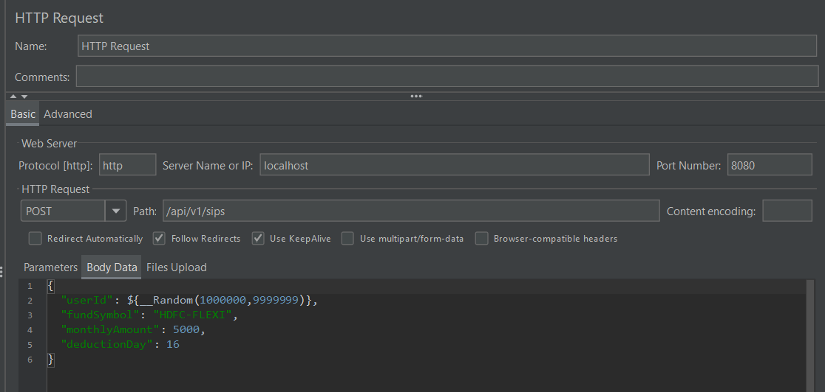
Figure 5 — HTTP Request Configuration
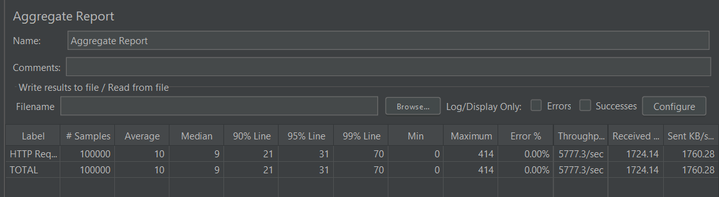
Figure 6 — Summary Report
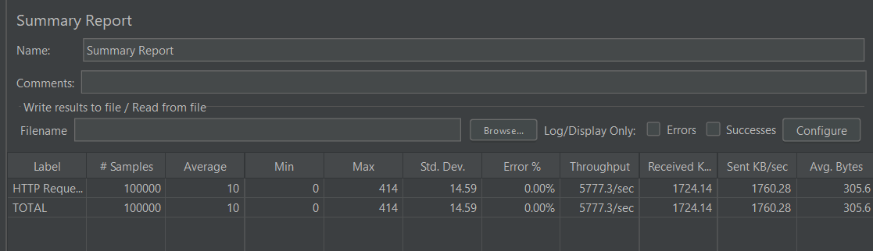
Figure 7 — Aggregate Report

Database Persistence Evidence — Test 2
The database count after the second workload was 200,004. Starting from the 100,004 rows remaining after Test 1, this represents another 100,000 persisted SIP records.
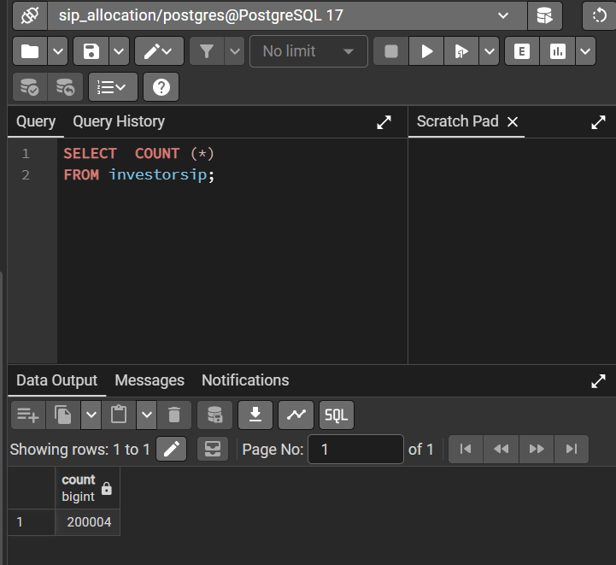
Figure 8 — PostgreSQL investorSIP row count after Test 2

Performance Results — Test 2
Metric | Result
Samples | 100,000
Average | 10 ms
Median | 9 ms
P90 | 21 ms
P95 | 31 ms
P99 | 70 ms
Minimum | 0 ms
Maximum | 414 ms
Standard Deviation | 14.59 ms
Error Rate | 0.00%
Throughput | 5,777.3 requests/sec
Received | 1,724.14 KB/sec
Sent | 1,760.28 KB/sec
Average Bytes | 305.6 bytes
Database Row Increase | 100,000

Test Comparison
Metric | Test 1 — 1000×100 | Test 2 — 100×1000
Total Requests | 100,000 | 100,000
Average | 234 ms | 10 ms
Median | 146 ms | 9 ms
P90 | 493 ms | 21 ms
P95 | 648 ms | 31 ms
P99 | 1,158 ms | 70 ms
Max | 4,679 ms | 414 ms
Std. Dev. | 232.00 ms | 14.59 ms
Error Rate | 0.00% | 0.00%
Throughput | 3,451.5 req/sec | 5,777.3 req/sec
Persisted Row Increase | 100,000 | 100,000

Analysis
• Both workloads completed all 100,000 HTTP requests with a 0.00% error rate.
• Test 1, which concentrated the workload across 1,000 threads, recorded higher latency and variability: 234 ms average, 146 ms median, and 1,158 ms P99.
• Test 2, which distributed the same request volume across 100 threads and more iterations, recorded lower latency: 10 ms average, 9 ms median, and 70 ms P99.
• Observed throughput was higher in Test 2 at 5,777.3 requests/sec compared with 3,451.5 requests/sec in Test 1.
• PostgreSQL row-count evidence shows a 100,000-row increase after each workload, matching the number of successful HTTP samples in the captured tests.

Best Overall Latency Result
Test 2 — High Iteration: 10 ms average latency, 9 ms median, 31 ms P95, and 70 ms P99, with a 0.00% error rate.

Highest Observed Throughput
Test 2 — High Iteration: 5,777.3 requests/sec with a 0.00% error rate.

Database Persistence Verification
The captured PostgreSQL counts provide an additional consistency check for this write endpoint. The table contained 100,004 rows after Test 1 and 200,004 after Test 2. With four pre-existing records, each 100,000-request workload added exactly 100,000 SIP rows in the captured environment.

Final Status
POST /api/v1/sips — TESTED & RECORDED
Both JMeter workload profiles completed successfully with 0.00% errors, and the accompanying database-count screenshots show corresponding persistence of the generated SIP records.
Note: These are local benchmark measurements for the captured development environment. They should not be presented as production capacity guarantees; results depend on the test machine, JVM state, PostgreSQL state, JMeter configuration, concurrency, and workload distribution.

